Paper
Arches or Winsor & Newton 300g soft grain

Tools
Paper towel
Mechanical pencil
Soft rubber, bread one
Tape
Water container
Spray, for water
Board

My palette colours
1-Pens gray
2- Sépia
3-Quinacridone Violet
4- Winsor Violet
5-Cobalt blue
6- Prussian blue
7-Phithalo blue
8-Cerulean Blue
9-Cobalt Turquoise light
10-Acqua green
11-Cadmiun free Lemon yellow
12-Yellow transparent
13-Cadmiun Orange
14-Cadmiun Red
15-Permanent Alisarin Crimson

Brands
Winsor & Newton

Brushes
-Petit gris number 6
-Round Peels - Kolinsky
Number 2, 5, 7 and 10
-Flat brush - One stroke 15mm and 25mm
-Tank 20 and 40mm – Optional

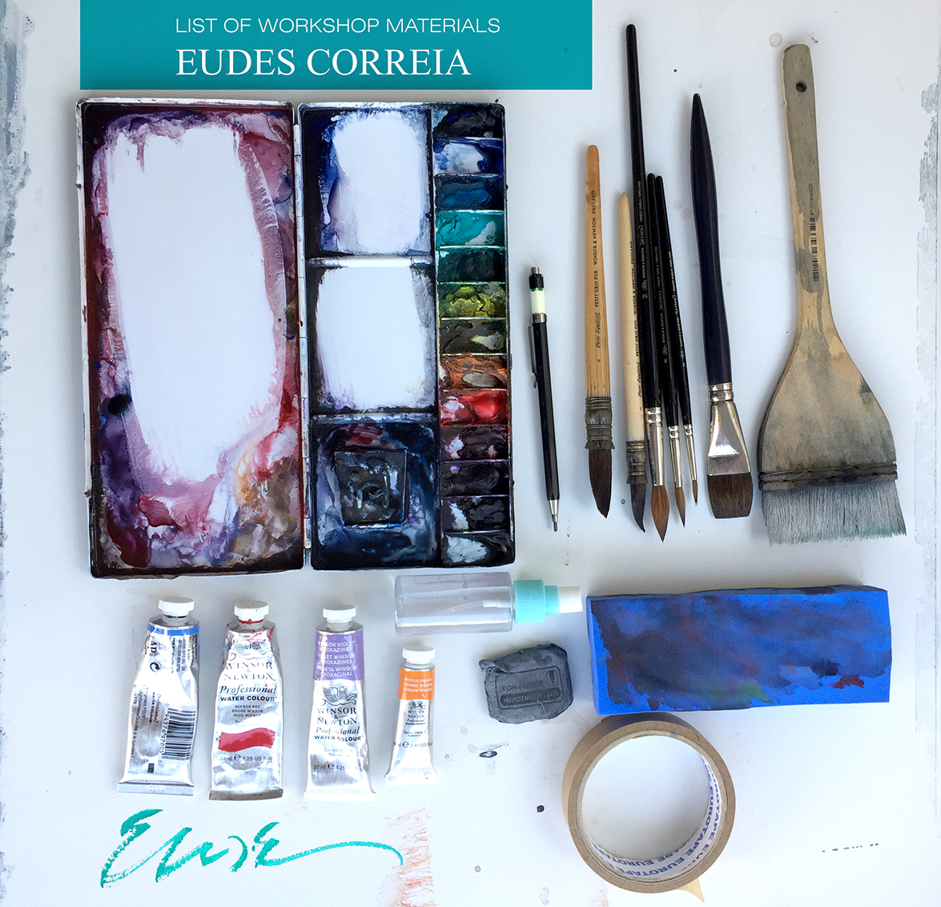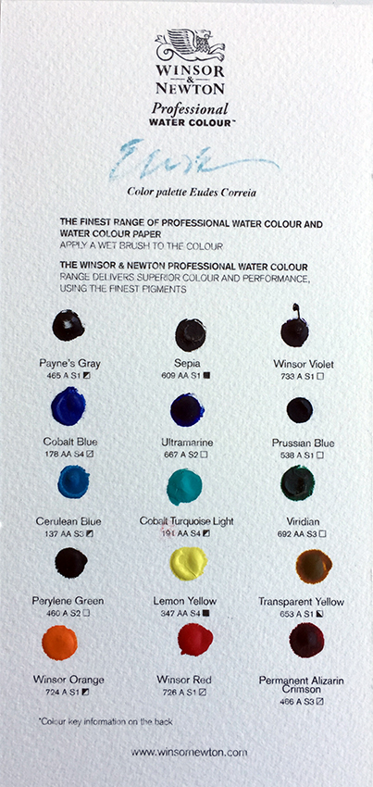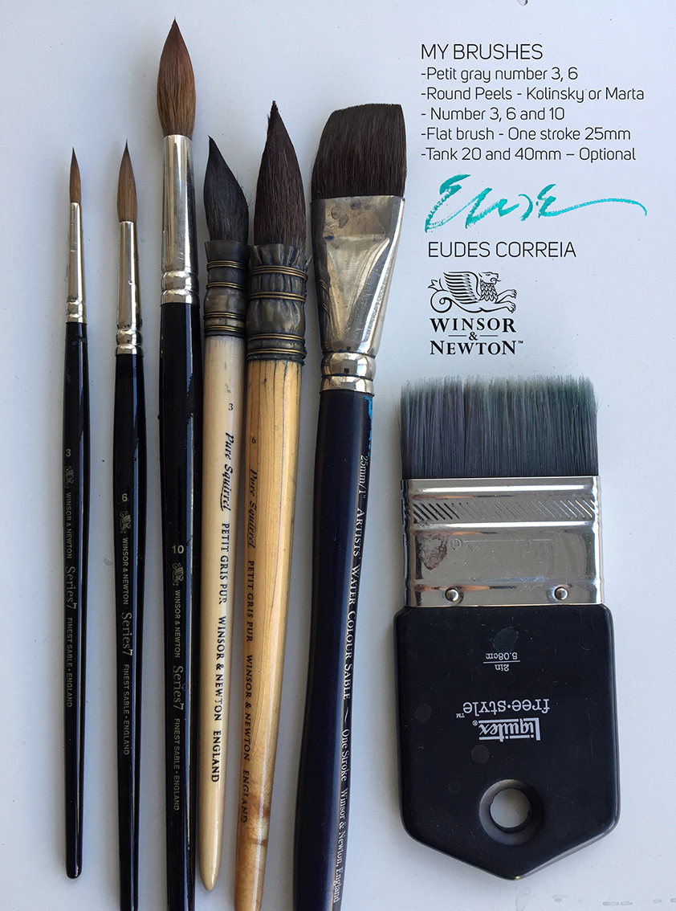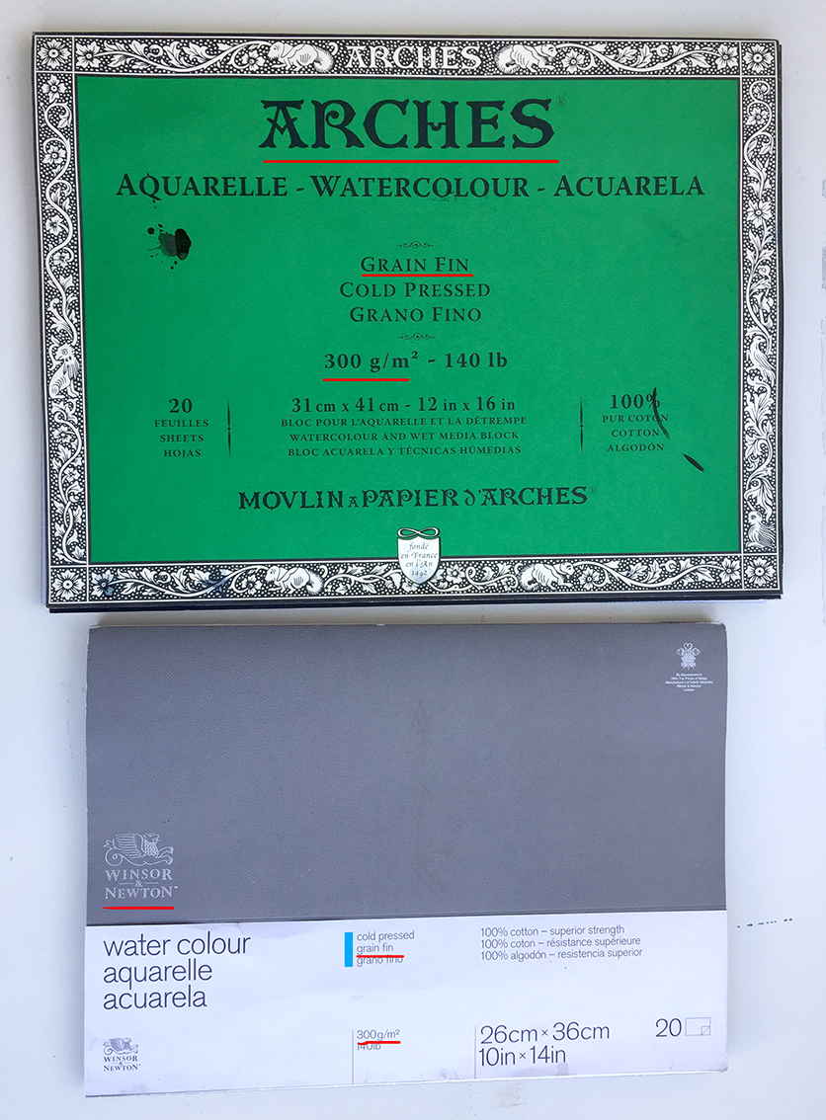
Paper
Arches or Winsor & Newton 300g soft grain

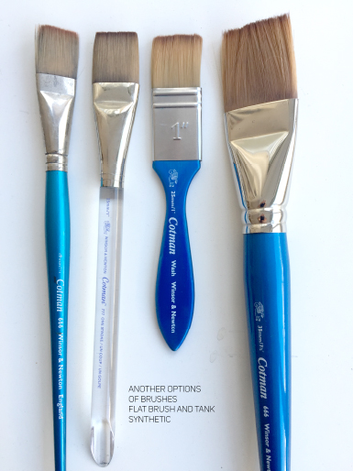

FLAT BRUSH AND TANK
ONE STROKE SYNTHETIC

